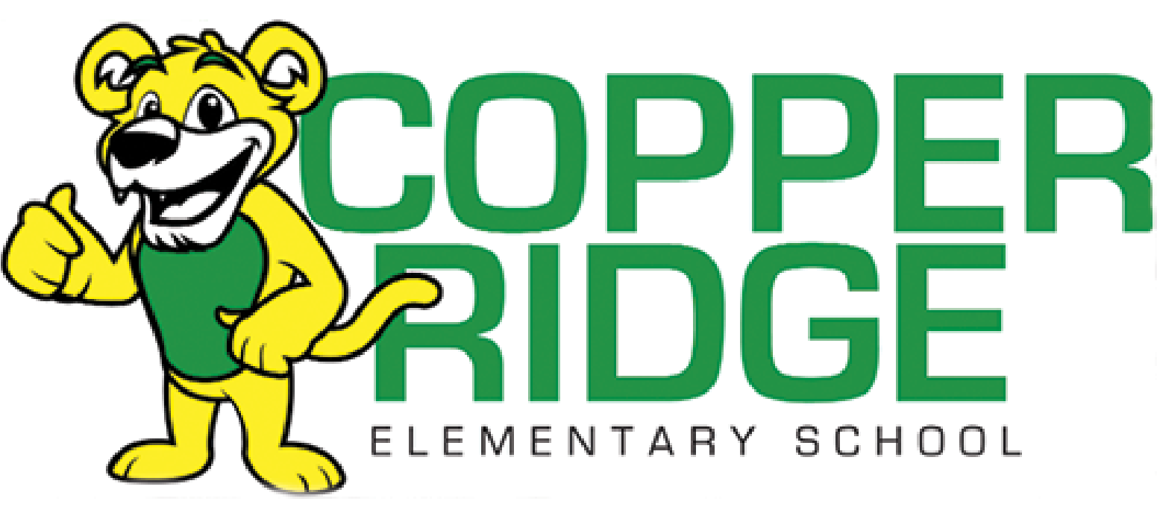

**2025/2026 Kindergarten Supply List**

* Large Backpack (no rolling ones)
* Plastic Pencil Box (labeled w/student name)
* Children’s Fiskar blunt metal scissors (labeled w/student name)
* 3 packs- 24 count Crayola crayons
* 2 Black dry erase markers (no colored dry erase markers)
* 12 glue sticks
* 1 pack of washable markers (labeled w/student name)
* 2 containers of playdough
* Headphones- *No earbuds (labeled w/student name)
* Water Bottle with flip-top spout (labeled w/student name)
* Send in an extra change of clothes for your child in a Ziploc bag-labeled

Optional Items: Kleenex, baby wipes, Ziploc bags(gallon, sandwich, or snack size) disinfectant wipes

**Watch store ads for sales this summer!**